**Software Requirements Specification Documentation**

* **Introduction**
  + **Purpose**

The purpose of this documentation is to layout the requirements of the users, software, and design. The purpose of the application itself to create an all-inclusive and diverse learning and teaching platform.

* + **Intended Audience**

This project intended audience is educational institutions or individuals who wish to have an immersive learning environment.

* + **Project Scope**

The purpose of the Virtual Classroom Dashboard is to ease educators and to create a convenient easy-to-use application for its diverse user group. The system includes a relational database that may include some object-oriented aspects. This system also includes a web-application that will focus on security and user experience.

* **Overall Description**
  + **Data Features**
    - **Entities**
    - User_Info:
      * UserID: Primary key – int not null
      * UserFname: varchar not null
      * UserLname: varchar not null
      * UserPhonNum: varchar null
      * UserEmail: varchar not null
      * UserLevel: varchar null
      * UserType: varchar not null (Student, Educator, Admin)
      * SchoolID: Foreign key – int not null
    - School:
      * SchoolID: Primary key – int not null
      * SchoolName: varchar not null
      * SchoolLevel: varchar not null (Elementary, Middle School, High School, College)
    - Courses:
      * CourseID: Primary Key – int not null
      * CourseName: varchar not null
      * CourseSection: int not null
      * CourseNumber: varchar not null
      * ClassNum: int not null
      * UserId: Foreign key int not null
      * SchoolID: Foreign key int not null
    - User_Course:
      * UserID: Foreign key int not null
      * CourseID: Foreign key int not null
    - Assignments:
      * AssignID: Primary key – int not null
      * AssignName: varchar not null
      * AssignDate: date not null
      * AssignDueDate: date time null
      * AssignDescription: varchar null
      * AssignFile: varchar null
      * AssignPoints: int not null
      * AssignType: varchar not null (Assignment, Project)
      * CourseID: Foreign key – int not null
    - User_Assignment:
      * AssignID: Foreign key – int not null
      * UserID: Foreign key – int not null
      * UserAssignFile: varchar not null
      * UserAssignGrade: int null
    - Assessment:
      * AssessID: Primary key – int not null
      * AssessName: varchar not null
      * AssessStartDate: datetime not null
      * AssessEndDate: datetime not null
      * AssessTimeLimit: int not null
      * AssessPoints: int not null
      * AssessType: varchar not null (Quiz, Exam)
      * CourseID: Foreign key – int not null
    - Questions:
      * QuestionID: Primary key – int not null
      * AssessID: Foreign key – int not null
      * Question: varchar null
      * QuestionImage: varchar null
      * QuestionType: varchar not null (short answer, multiple choice, multiple selection)
    - Options:
      * OptionID: Primary key – int not null
      * QuestionID: Foreign key – int not null
      * Option: varchar not null
      * IsCorrect: bool (0, 1)
    - Assessment_Result
      * AssessResultID: Primary key – int not null
      * OptionID: Foreign key – int not null
      * QuestionID: Foreign key – int not null
      * UserID: Foreign Key – int not null
      * IsCorrect: bool (0, 1)
      * AssessDescription: varchar null
    - User_Assess_Result:
      * AssessID: Foreign key – int not null
      * UserID: ForeignKey – int not null
      * UserAssessGrade – int null
    - Grade_Format:
      * GradeFormatID: Primary key – int not null
      * CourseID: Foreign key – int not null
      * GradeFSection: varchar not null (Assignment, Project, Quiz, Exam)
      * GradeFPercent: percentage not null
    - Grade:
      * GradeID: Primary key – int not null
      * CourseID: Foreign key – int not null
      * UserID: Foreign key – int not null
      * GradePoints: int null
      * GradePercent: percentage default 100%
    - Announcements:
      * AnnounceID: Primary key – int not null
      * CouseID: Foreign key – int not null
      * UserID: Foreign key – int not null
      * AnnounceTitle: varchar not null
      * AnnounceDesc: varchar not null
    - Discussion:
      * DiscussionID: Primary key – int not null
      * CouseID: Foreign key – int not null
      * UserID: Foreign key – int not null
      * DiscussionTitle: varchar not null
      * DiscussionDesc: varchar not null
      * DiscussionDate: datetime not null
    - Discussion_Reply:
      * DiscussReplyID: Primary key – int not null
      * DiscussionID: Foreign key – int not null
      * UserID: Foreign key – int not null
      * DiscussReplyDesc: varchar not null
      * DiscussReplyDate: datetime not null
  + **ER Diagram**

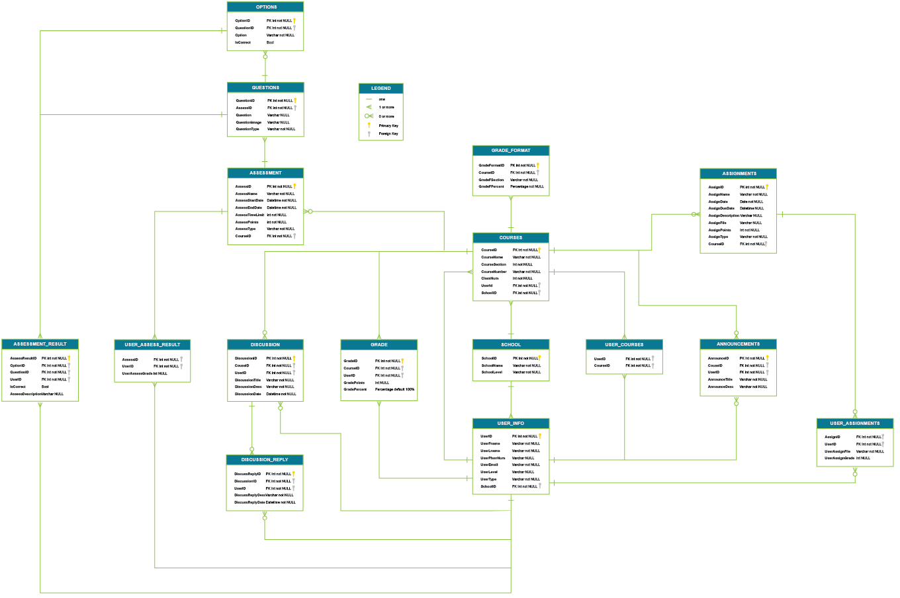

* + **Schema Diagram**

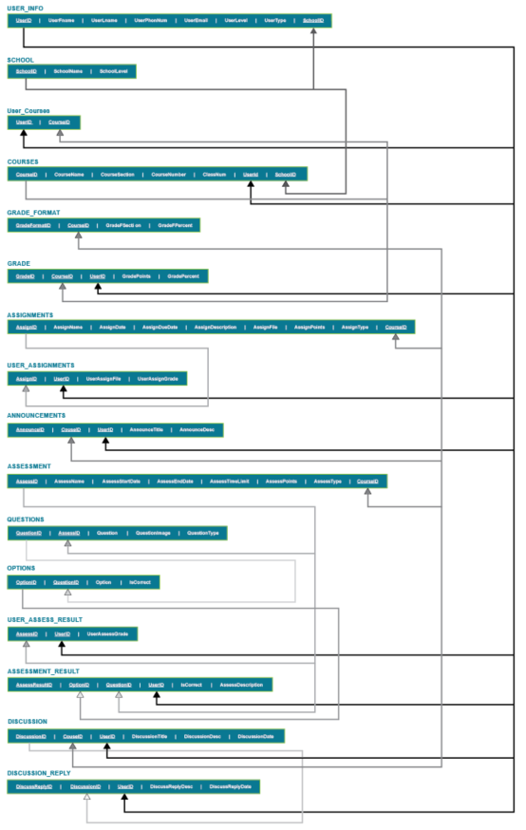

* + **User Classes and Characteristics**

Students:

* Insert quiz/exam/assignment answers
* upload documentation
* view quiz/exam/assignment
* Get all grades/classes/announcements
* View grades/classes/announcements
* Calculate grade average/exam scores/assignment scores/quiz scores

Educators:

Administration:

* + **Operating Environment**
    - Distributed database
    - Client/server system
    - Browser choice: Chrome (Zoom does not work well in safari)
    - Database: SQL + database
  + **Design and Implementation Constraints**
  + **Assumptions and Dependencies**
* **System Features** 
  + **Functional Requirements**
* **External Interface Requirements**
  + **User Interfaces**

Front-end: HTML / CSS / maybe JavaScript

Back-end: C# ASP.NET

* + **Software Interfaces**

Users need Window or OSX operating system

A browser that supports zoom (preferably chrome, safari should not be used)

* + **Communication Interfaces**

This web application supports all browsers, but the feature zoom will not.

* **Nonfunctional Requirements**
  + **Performance Requirements**
  + **Safety Requirements**
  + **Security Requirements**
  + **Software Quality Attributes**